Assignment 3.1
Listing the components of Hadoop2.X
Hadoop2.X
Apache Foundation has pre-defined set of utilities and libraries that can be used by other modules within the Hadoop ecosystem. For example, if HBase and Hive want to access HDFS they need to make of Java archives (JAR files) that are stored in Hadoop Common.
What is new in Hadoop2.X
- Hadoop 2.x has some common Hadoop API which can easily be integrated with any third party applications to work with Hadoop
- It has some new Java APIs and features in HDFS and MapReduce which are known as HDFS2 and MR2 respectively
- New architecture has added the architectural features like HDFS High Availability and HDFS Federation
- Hadoop 2.x not using Job Tracker and Task Tracker daemons for resource management now on-wards, it is using YARN (Yet Another Resource Negotiator) for Resource Management

Hadoop Distributed File System
The default big data storage layer for Apache Hadoop is HDFS. HDFS is the “Secret Sauce” of Apache Hadoop components as users can dump huge datasets into HDFS and the data will sit there nicely until the user wants to leverage it for analysis. HDFS component creates several replicas of the data block to be distributed across different clusters for reliable and quick data access. HDFS comprises of 3 important components-NameNode, DataNode and Secondary NameNode. HDFS operates on a Master-Slave architecture model where the NameNode acts as the master node for keeping a track of the storage cluster and the DataNode acts as a slave node summing up to the various systems within a Hadoop cluster.
Hadoop Master and Slave Architecture
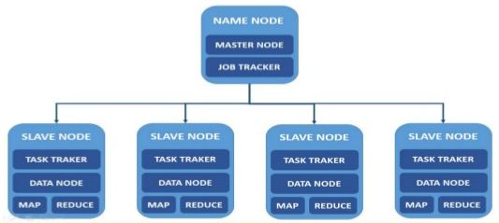

HDFS Use Case
Nokia deals with more than 500 terabytes of unstructured data and close to 100 terabytes of structured data. Nokia uses HDFS for storing all the structured and unstructured data sets as it allows processing of the stored data at a petabyte scale.

HDFS High Availability (HA)
Problem: As you know in Hadoop 1.x architecture Name Node was a single point of failure, which means if your Name Node daemon is down somehow, you don’t have access to your Hadoop Cluster than after. How to deal with this problem?
Solution: Hadoop 2.x is featured with Name Node HA which is referred as HDFS High Availability (HA).
- Hadoop 2.x supports two Name Nodes at a time one node is active and another is standby node
- Active Name Node handles the client operations in the cluster
- StandBy Name Node manages metadata same as Secondary Name Node in Hadoop 1.x
- When Active Name Node is down, Standby Name Node takes over and will handle the client operations then after
- HDFS HA can be configured by two ways
  - Using Shared NFS Directory
  - Using Quorum Journal Manager

HDFS Federation
Problem: HDFS uses namespaces for managing directories, file and block level information in cluster. Hadoop 1.x architecture was able to manage only single namespace in a whole cluster with the help of the Name Node (which is a single point of failure in Hadoop 1.x). Once that Name Node is down you loose access of full cluster data. It was not possible for partial data availability based on name space.
Solution: Above problem is solved by HDFS Federation i Hadoop 2.x Architecture which allows to manage multiple namespaces by enabling multiple Name Nodes. So on HDFS shell you have multiple directories available but it may be possible that two different directories are managed by two active Name Nodes at a time.
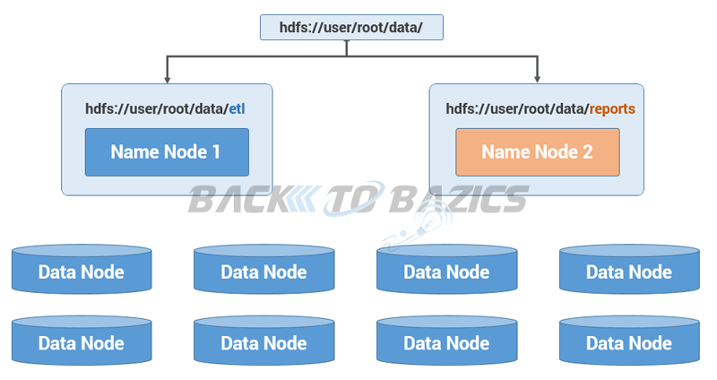

Hadoop 2.x Architecture In Detail
Hadoop2 Architecture has mainly 2 set of daemons
- HDFS 2.x Daemons: Name Node, Secondary Name Node (not required in HA) and Data Nodes
- MapReduce 2.x Daemons (YARN): Resource Manager, Node Manager

HDFS 2.x Daemons
The working methodology of HDFS 2.x daemons is same as it was in Hadoop 1.x Architecture with following differences.
- Hadoop 2.x allows Multiple Name Nodes for HDFS Federation
- New Architecture allows HDFS High Availability mode in which it can have Active and StandBy Name Nodes (No Need of Secondary Name Node in this case)
- Hadoop 2.x Non HA mode has same Name Node and Secondary Name Node working same as in Hadoop 1.x architecture
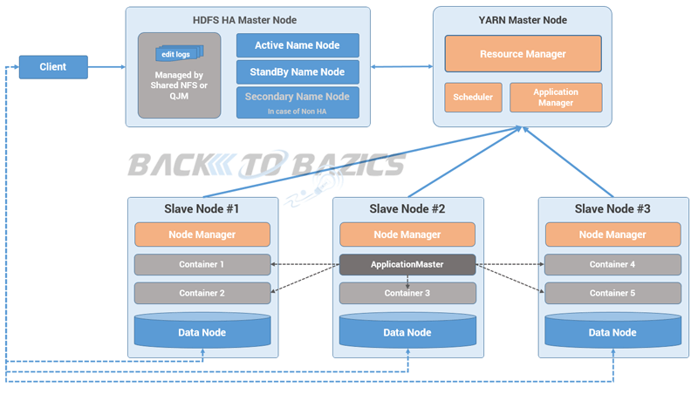

MapReduce- Distributed Data Processing Framework of Apache Hadoop
MapReduce is a Java-based system created by Google where the actual data from the HDFS store gets processed efficiently. MapReduce breaks down a big data processing job into smaller tasks. MapReduce is responsible for the analysing large datasets in parallel before reducing it to find the results. In the Hadoop ecosystem, Hadoop MapReduce is a framework based on YARN architecture. YARN based Hadoop architecture, supports parallel processing of huge data sets and MapReduce provides the framework for easily writing applications on thousands of nodes, considering fault and failure management.
The basic principle of operation behind MapReduce is that the “Map” job sends a query for processing to various nodes in a Hadoop cluster and the “Reduce” job collects all the results to output into a single value. Map Task in the Hadoop ecosystem takes input data and splits into independent chunks and output of this task will be the input for Reduce Task. In The same Hadoop ecosystem Reduce task combines Mapped data tuples into smaller set of tuples. Meanwhile, both input and output of tasks are stored in a file system. MapReduce takes care of scheduling jobs, monitoring jobs and re-executes the failed task.
MapReduce framework forms the compute node while the HDFS file system forms the data node. Typically in the Hadoop ecosystem architecture both data node and compute node are considered to be the same.
The delegation tasks of the MapReduce component are tackled by two daemons- Job Tracker and Task Tracker as shown in the image below –

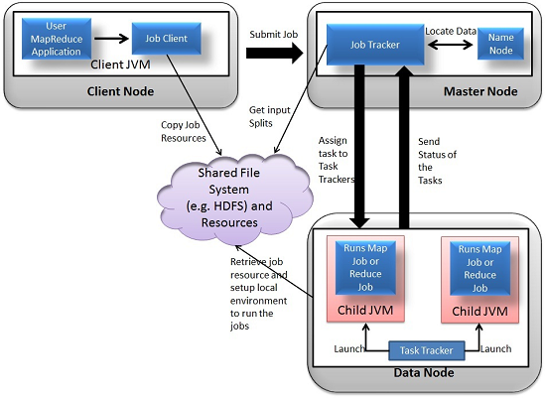

MapReduce Use Case
Skybox has developed an economical image satellite system for capturing videos and images from any location on earth. Skybox uses Hadoop to analyse the large volumes of image data downloaded from the satellites. The image processing algorithms of Skybox are written in C++. Busboy, a proprietary framework of Skybox makes use of built-in code from java based MapReduce framework.

YARN
YARN forms an integral part of Hadoop 2.0.YARN is great enabler for dynamic resource utilization on Hadoop framework as users can run various Hadoop applications without having to bother about increasing workloads.
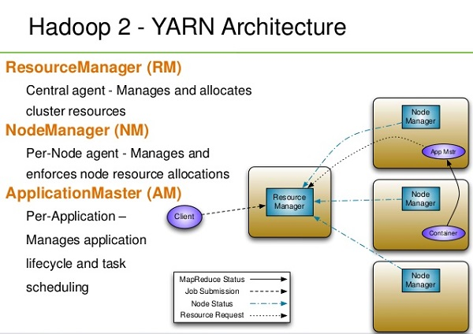

Key Benefits of Hadoop 2.0 YARN Component-
- It offers improved cluster utilization
- Highly scalable
- Beyond Java
- Novel programming models and services
- Agility

YARN Use Case
Yahoo has close to 40,000 nodes running Apache Hadoop with 500,000 MapReduce jobs per day taking 230 compute years extra for processing every day. YARN at Yahoo helped them increase the load on the most heavily used Hadoop cluster to 125,000 jobs a day when compared to 80,000 jobs a day which is close to 50% increase.

Data Access Components of Hadoop Ecosystem

Pig-
​Apache Pig is a convenient tools developed by Yahoo for analysing huge data sets efficiently and easily. It provides a high level data flow language Pig Latin that is optimized, extensible and easy to use. The most outstanding feature of Pig programs is that their structure is open to considerable parallelization making it easy for handling large data sets.

Pig Use Case
The personal healthcare data of an individual is confidential and should not be exposed to others. This information should be masked to maintain confidentiality but the healthcare data is so huge that identifying and removing personal healthcare data is crucial. Apache Pig can be used under such circumstances to de-identify health information.

Hive
​ Hive developed by Facebook is a data warehouse built on top of Hadoop and provides a simple language known as HiveQL similar to SQL for querying, data summarization and analysis. Hive makes querying faster through indexing.

Hive Use Case
Hive simplifies Hadoop at Facebook with the execution of 7500+ Hive jobs daily for Ad-hoc analysis, reporting and machine learning.

Data Integration Components of Hadoop Ecosystem- Sqoop and Flume

Sqoop
​​Sqoop component is used for importing data from external sources into related Hadoop components like HDFS, HBase or Hive. It can also be used for exporting data from Hadoop o other external structured data stores. Sqoop parallelized data transfer, mitigates excessive loads, allows data imports, efficient data analysis and copies data quickly.

Sqoop Use Case-
Online Marketer Coupons.com uses Sqoop component of the Hadoop ecosystem to enable transmission of data between Hadoop and the IBM Netezza data warehouse and pipes backs the results into Hadoop using Sqoop.

Flume
​Flume component is used to gather and aggregate large amounts of data. Apache Flume is used for collecting data from its origin and sending it back to the resting location (HDFS).Flume accomplishes this by outlining data flows that consist of 3 primary structures channels, sources and sinks. The processes that run the dataflow with flume are known as agents and the bits of data that flow via flume are known as events.

Flume Use Case
Twitter source connects through the streaming API and continuously downloads the tweets (called as events). These tweets are converted into JSON format and sent to the downstream Flume sinks for further analysis of tweets and retweets to engage users on Twitter.

Data Storage Component of Hadoop Ecosystem –HBase

HBase
HBase is a column-oriented database that uses HDFS for underlying storage of data. HBase supports random reads and also batch computations using MapReduce. With HBase NoSQL database enterprise can create large tables with millions of rows and columns on hardware machine. The best practice to use HBase is when there is a requirement for random ‘read or write’ access to big datasets.

HBase Use Case
Facebook is one the largest users of HBase with its messaging platform built on top of HBase in 2010.HBase is also used by Facebook for streaming data analysis, internal monitoring system, Nearby Friends Feature, Search Indexing and scraping data for their internal data warehouses.

Monitoring, Management and Orchestration Components of Hadoop Ecosystem- Oozie and Zookeeper

Oozie-
​Oozie is a workflow scheduler where the workflows are expressed as Directed Acyclic Graphs. Oozie runs in a Java servlet container Tomcat and makes use of a database to store all the running workflow instances, their states ad variables along with the workflow definitions to manage Hadoop jobs (MapReduce, Sqoop, Pig and Hive).The workflows in Oozie are executed based on data and time dependencies.

Oozie Use Case:
The American video game publisher Riot Games uses Hadoop and the open source tool Oozie to understand the player experience.
Zookeeper
​Zookeeper is the king of coordination and provides simple, fast, reliable and ordered operational services for a Hadoop cluster. Zookeeper is responsible for synchronization service, distributed configuration service and for providing a naming registry for distributed systems.

Zookeeper Use Case
Found by Elastic uses Zookeeper comprehensively for resource allocation, leader election, high priority notifications and discovery. The entire service of Found built up of various systems that read and write to Zookeeper.
Several other common Hadoop ecosystem components include: Avro, Cassandra, Chukwa, Mahout, HCatalog, Ambari and Hama. By implementing Hadoop using one or more of the Hadoop ecosystem components, users can personalize their big data experience to meet the changing business requirements. The demand for big data analytics will make the elephant stay in the big data room for quite some time.
AMBARI
A Hadoop component, Ambari is a RESTful API which provides easy to use web user interface for Hadoop management. Ambari provides step-by-step wizard for installing Hadoop ecosystem services. It is equipped with central management to start, stop and re-configure Hadoop services and it facilitates the metrics collection, alert framework, which can monitor the health status of the Hadoop cluster. Recent release of Ambari has added the service check for Apache spark Services and supports Spark 1.6.
MAHOUT
Mahout is an important Hadoop component for machine learning, this provides implementation of various machine learning algorithms. This Hadoop component helps with considering user behavior in providing suggestions, categorizing the items to its respective group, classifying items based on the categorization and supporting in implementation group mining or itemset mining, to determine items which appear in group.
Apache Kafka
A distributed public-subscribe message developed by LinkedIn that is fast, durable and scalable.Just like other Public-Subscribe messaging systems ,feeds of messages are maintained in topics.
Apache Kafka Use Cases
- Spotify uses Kafka as a part of their log collection pipeline.
- Airbnb uses Kafka in its event pipeline and exception tracking.
- At FourSquare ,Kafka powers online-online and online-offline messaging.
- Kafka power's MailChimp's data pipeline.

MapReduce 2.x Daemons (YARN)
MapReduce2 has replace old daemon process Job Tracker and Task Tracker with YARN components Resource Manager and Node Manager respectively. These two components are responsible for executing distributed data computation jobs in Hadoop 2(Refer my post on YARN Architecture for further understanding).

Resource Manager
- This daemon process runs on master node (may run on the same machine as name node for smaller clusters)
- It is responsible for getting job submitted from client and schedule it on cluster, monitoring running jobs on cluster and allocating proper resources on the slave node
- It communicates with Node Manager daemon process on the slave node to track the resource utilization
- It uses two other processes named Application Manager and Scheduler for MapReduce task and resource management
Node Manager
- This daemon process runs on slave nodes (normally on HDFS Data node machines)
- It is responsible for coordinating with Resource Manager for task scheduling and tracking the resource utilization on the slave node
- It also reports the resource utilization back to the Resource Manager
- It uses other daemon process like Application Master and Container for MapReduce task scheduling and execution on the slave node

